Bash-Scripting assignment-02.
Bash Script Tasks
- Create a bash script tocheck if a directory is available or not.
vi tocheck.bash
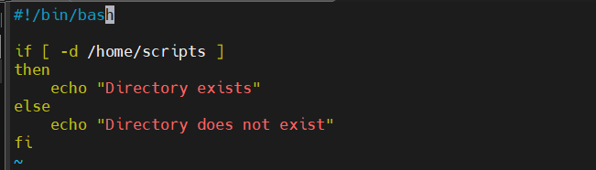
input

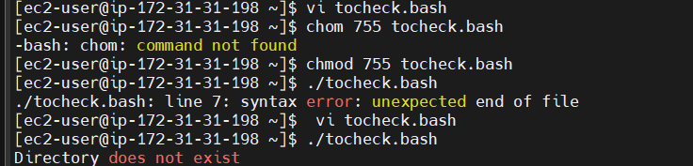
Output

2.Create a bash script tocreate multiple files.
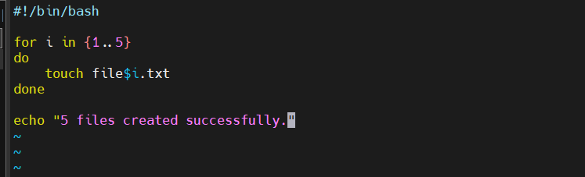
vi tocreate.bash

Explanation:
- for i in {1..5} → Loops from 1 to 5.
- touch file$i.txt → Creates file1.txt, file2.txt, ..., file5.txt.
- echo → Displays a success message.

Output
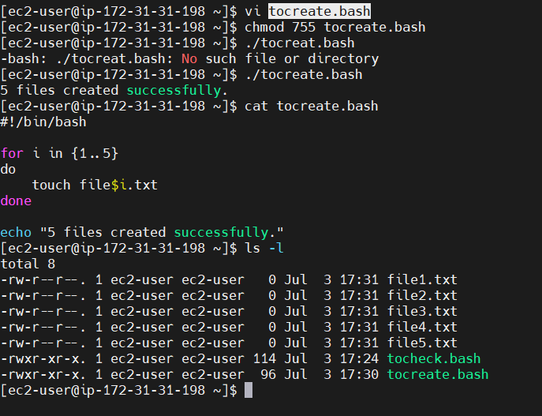

3.Create a bash script totake a backup of a directory
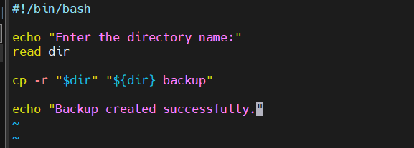
vi totake.bash

- read dir → Reads the directory name from the user.
- cp -r → Copies the directory and all its contents.
- "${dir}_backup" → Creates a backup directory with _backup appended to the original name.
- echo → Displays a success message.
output
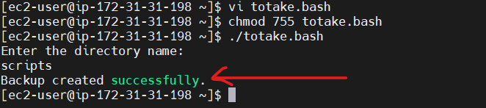

4.Create a bash script toinstall Nginx on an EC2 server.
vi toinstall.bash
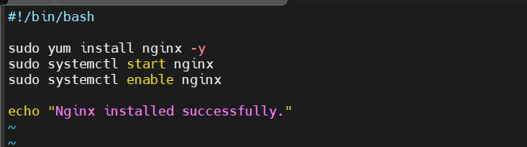
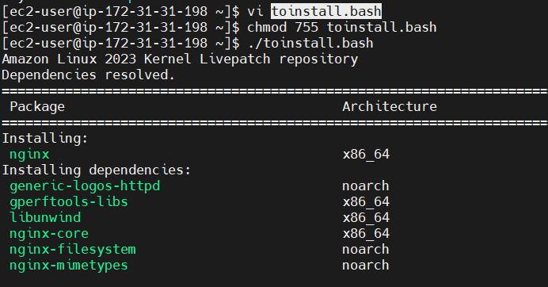
Output

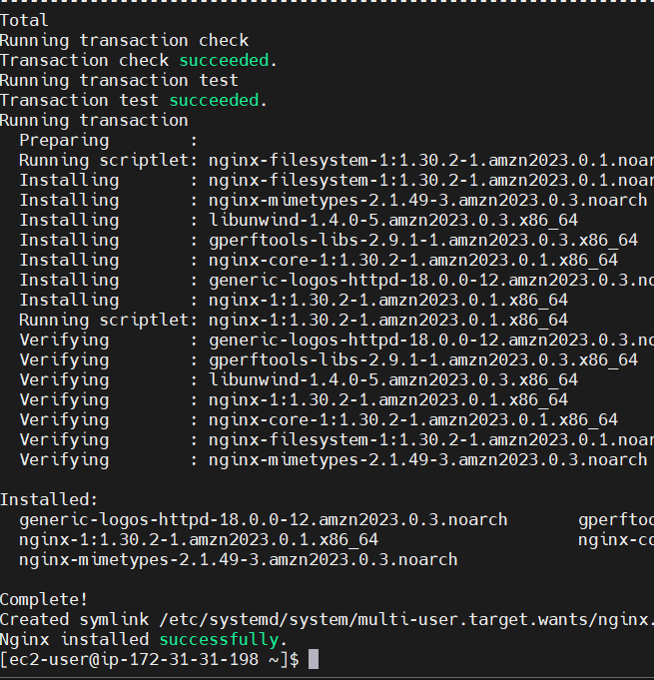

5.Create a bash script toinstall Apache Tomcat on an EC2 server
Command : vi toinstalltomcat.bash
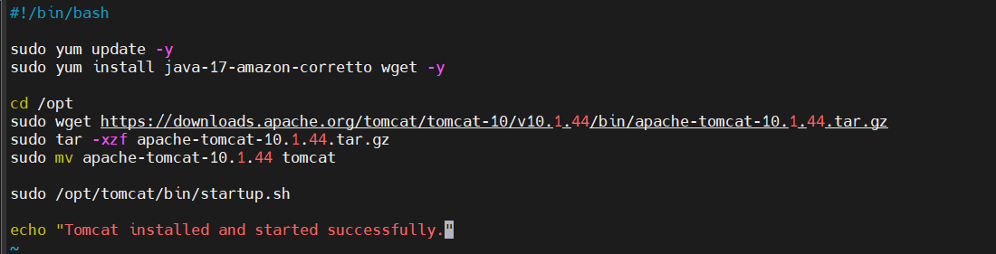
Output
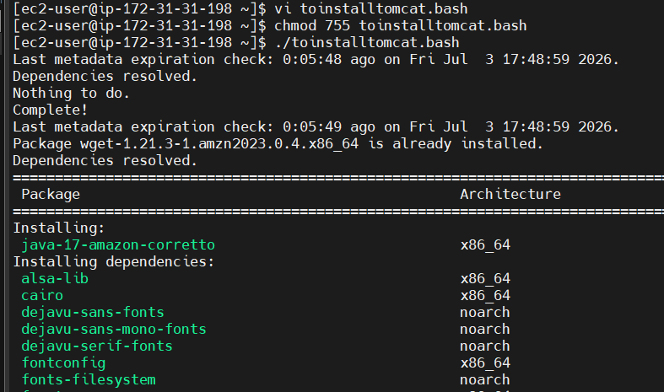
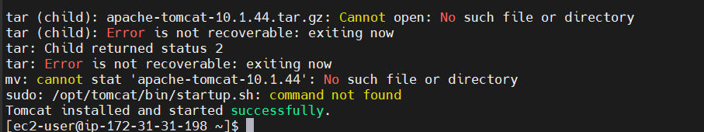

6. Create a bash script tocheck if the Nginx service is running, if not running then script should start the service.
Command : vi tocheck
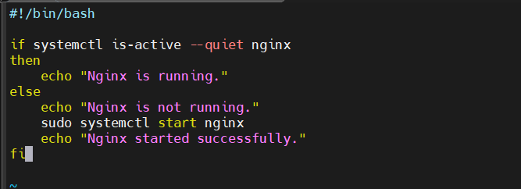

systemctl is-active --quiet nginx → Checks whether the Nginx service is running.
If Nginx is running, it displays:
Nginx is running.
If Nginx is not running, it:
- Starts the service using sudo systemctl start nginx
- Displays:
Output
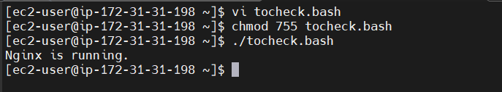

7. Create a bash script for acalculator.
Command :vi calculator.bash
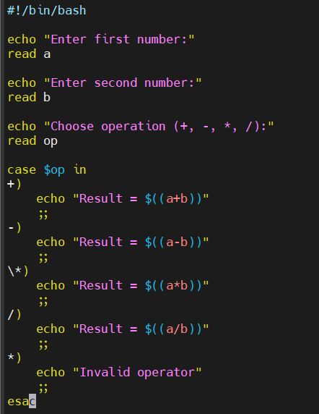

#!/bin/bash → Tells the system to run the script using the Bash shell.
echo → Displays a message to the user.
read a and read b → Take two numbers as input.
read op → Takes the arithmetic operator (+, -, *, /) from the user.
case $op in → Checks which operator the user entered.
$((...)) → Performs arithmetic calculations.
- $((a+b)) → Addition
- $((a-b)) → Subtraction
- $((a*b)) → Multiplication
- $((a/b)) → Division
*) → Executes if the user enters an invalid operator.
esac → Ends the case statement.
Output
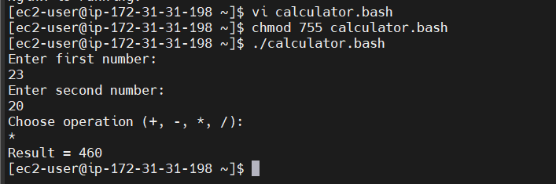

8. Create a bash script tocheck if a directory exists, if not then create a directory.
Command : vi tocheck.bash
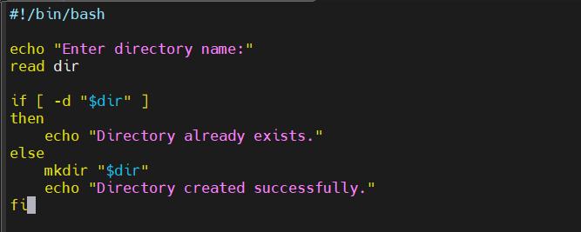

read dir → Reads the directory name.
-d → Checks if the directory exists.
mkdir → Creates the directory if it doesn't exist.
echo → Displays the result.

Output
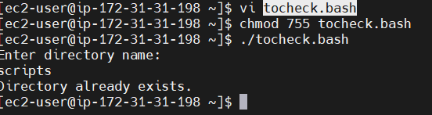
New created
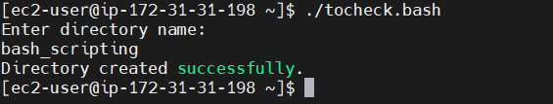

9. Create a bash script todelete the last 3 lines of a file.
Commad : vi todelete.bash
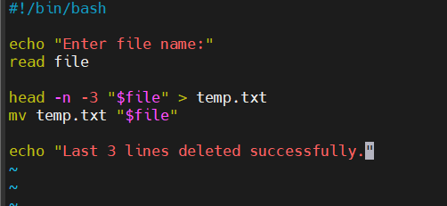
read file → Reads the file name.
head -n -3 → Displays all lines except the last 3.
> → Saves the output to a temporary file.
mv → Replaces the original file with the updated file.
echo → Displays a success message

Output
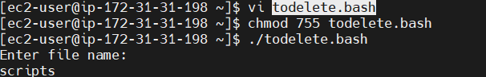

10. Bash script to monitor cpu and if it is more than 80% then send email notification.
Command : vi cpu.bash
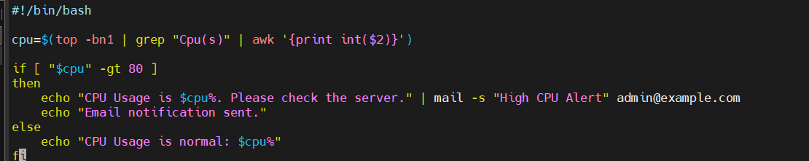
top -bn1 → Gets the current CPU usage.
awk → Extracts the CPU usage value.
if [ "$cpu" -gt 80 ] → Checks if CPU usage is greater than 80%.
mail -s → Sends an email notification.
echo → Displays the status

Output
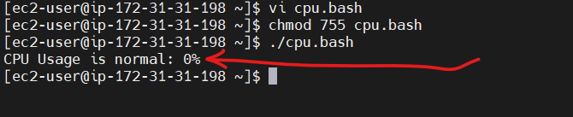

11. Bash script to monitor disk space and if it is more than 80% then send email notification.
Command:vi monitordeskspace.bash
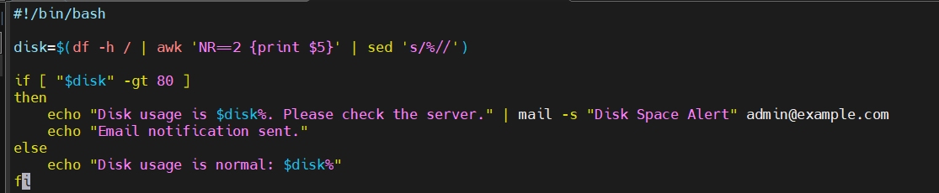
df -h / → Checks disk usage of the root (/) filesystem.
awk 'NR==2 {print $5}' → Extracts the disk usage percentage.
sed 's/%//' → Removes the % symbol.
if [ "$disk" -gt 80 ] → Checks if disk usage is greater than 80%.
mail -s → Sends an email alert.
echo → Displays the status.

Output
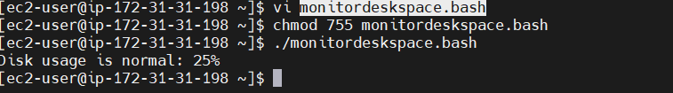

12. Bash script to monitor memory and if it is more than 80% then send email notification.
Command :vi monitormemory.bash
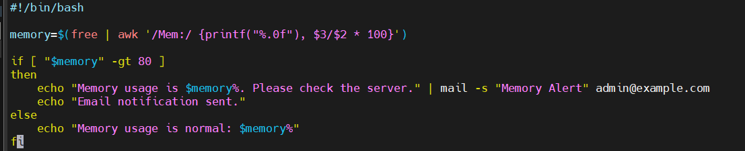
free → Displays memory usage.
awk → Calculates the memory usage percentage.
if [ "$memory" -gt 80 ] → Checks if memory usage is greater than 80%.
mail -s → Sends an email notification.
echo → Displays the status.
Output
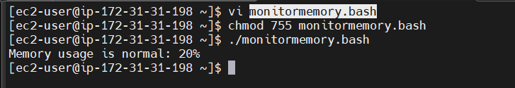

Crontab Entries
Step 1: Check your Amazon Linux version
cat /etc/os-release
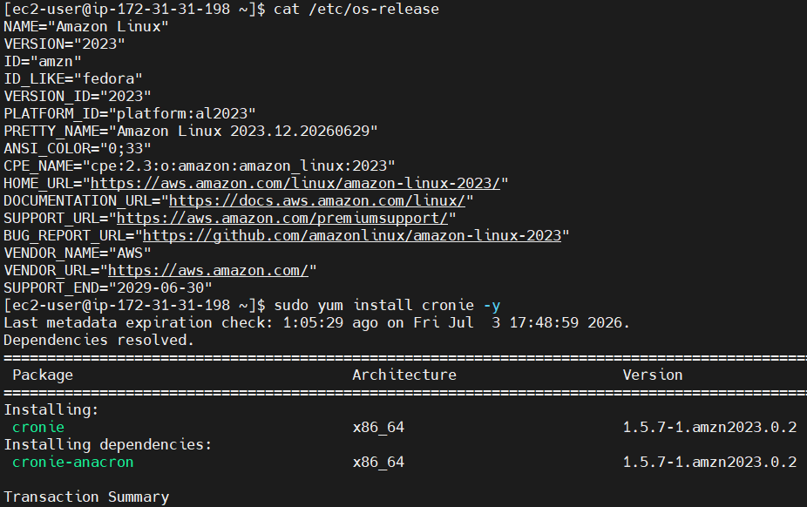
Step 2: Install cron For Amazon Linux 2:
sudo yum install cronie -y
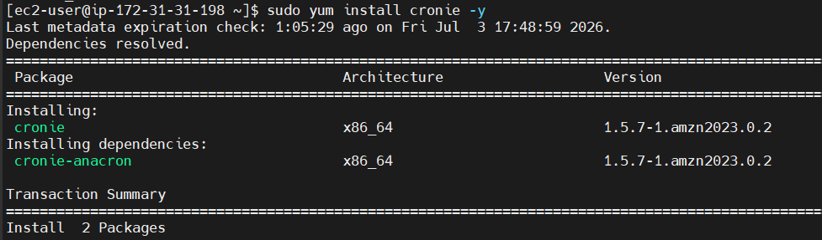
Step 3: Start the cron service
sudo systemctl start crond
sudo systemctl enable crond
sudo systemctl status crond
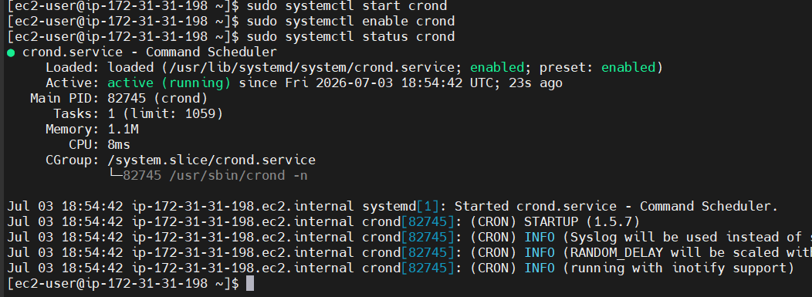

Exercise: Crontab Entries

1.April 5th Midnight
Step 1: Edit the crontab
crontab -e
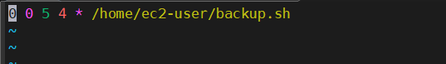
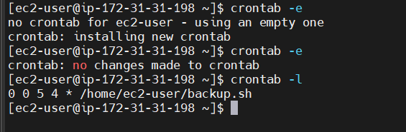

- 5th of Every November, January, Juneif it is a Thursday

Step 1: Create a Script
Create a new script file.
touch myscript.sh
vi myscript.sh

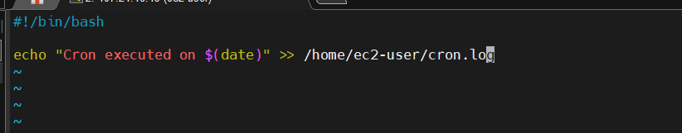

Step:2 permission and execute
Permission- Chmod 755 myscript.sh
Execute --./ myscript.sh
Read --Cat /home/ec2-user/cron.log

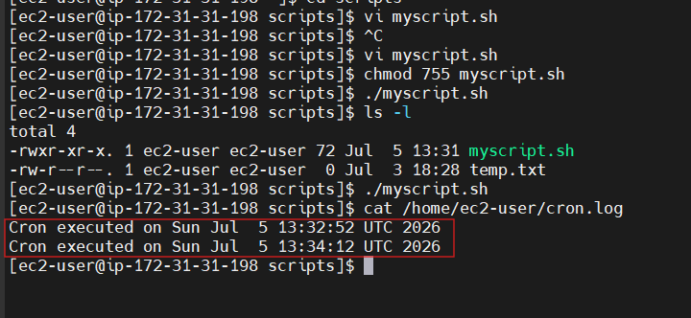

Step 3: Open the Crontab
Edit your crontab:
crontab -e
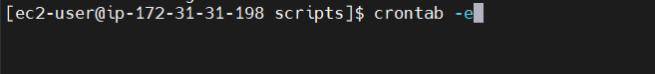

Step 4: Add the Cron Entry
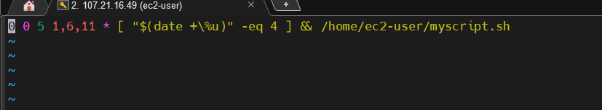

Step 4: Verify the Crontab
Run:
crontab -l 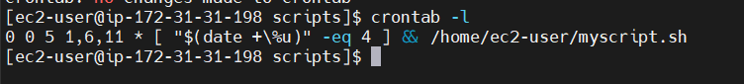

Step 5: Test
temporarily schedule it to run every minute.
crontab -e
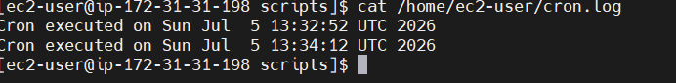
* * * * * /home/ec2-user/myscript.sh

3.At 05 and 27th minutes of 9, 10, 11hours every day
Step 1: Cron Format
* * * * *
│ │ │ │ │
│ │ │ │ └── Day of Week
│ │ │ └──── Month
│ │ └────── Day of Month
│ └──────── Hour
└────────── Minute
1.Open the crontab:
crontab -e

- Add the following line:
5,27 9,10,11 * * * /home/ec2-user/myscript.sh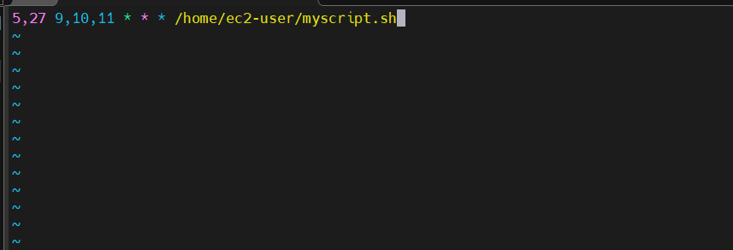
- Verify the cron job:
crontab -l
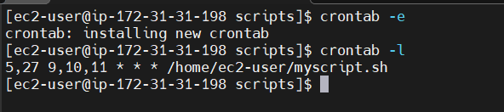
- 34 minutesof9th houron15th August

Step 1: Understand the Cron Format
A cron job has 5 time fields and then the command.
* * * * * command
│ │ │ │ │
│ │ │ │ └── Day of Week (0–7)
│ │ │ └──── Month (1–12)
│ │ └────── Day of Month (1–31)
│ └──────── Hour (0–23)
└────────── Minute (0–59)

Step 2: Fill Each Field
The question says:
- 34 minutes → Minute = 34
- 9th hour → Hour = 9
- 15th August → Day = 15, Month = 8
- Every year → Day of Week = *
So the cron expression becomes:
34 9 15 8 *

Step 3: Create a Script
Create a file:
touch independence.sh
Check:
ls
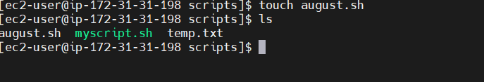
Step 4: Edit the Script
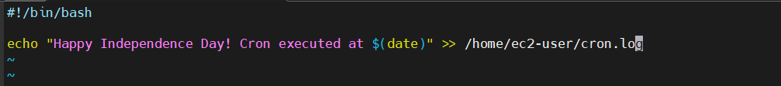
vi independence.sh

Step 5: Give Execute Permission
chmod +x independence.sh
Verify:
ls -l independence.sh
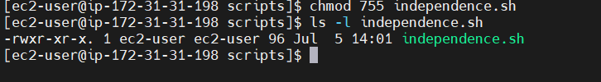

Step 6: Test the Script
Run it manually:
./independence.sh 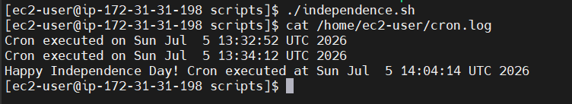

Step 7: Open Crontab
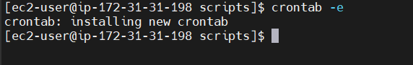
crontab -e

Step 8: Add the Cron Entry
Add this line:
34 9 15 8 * /home/ec2-user/independence.sh 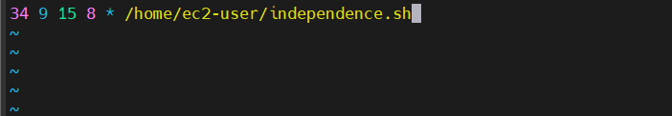

Step 11: Verify
Check the cron jobs:
crontab -l
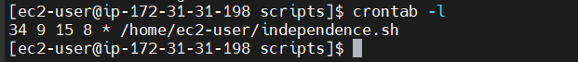

5.Every midnight
Step 1: Create a Script
vi bashscript.sh 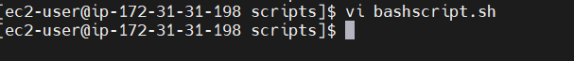
Add:
#!/bin/bash
echo "Cron ran at $(date)" >> /home/ec2-user/cron.log 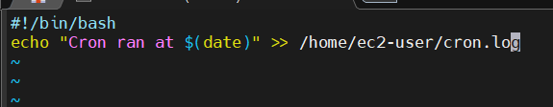
Step 3: persmissions
chmod 755 bashscript.sh
Step 4: Open Crontab
crontab -e
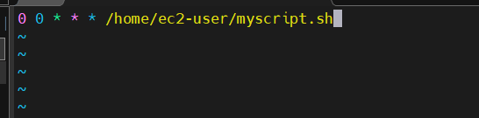
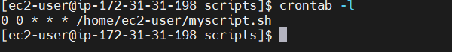
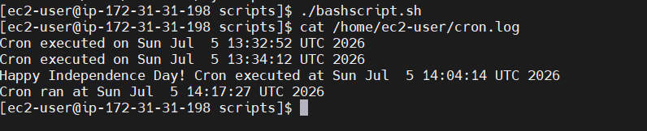

6.Every Weekend (Saturday night 11:59 PM)
Step 1: Open crontab
crontab -e
Step 2: Add the cron entry
59 23 * * 6 /home/ec2-user/myscript.sh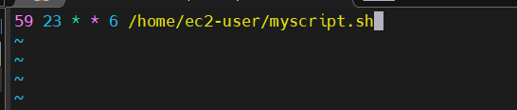

Step 3: Verify
crontab -l
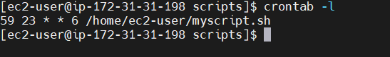

7.After every reboot

Step 1: Create a Script
vi /home/ec2-user/reboot.sh 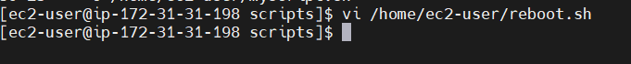
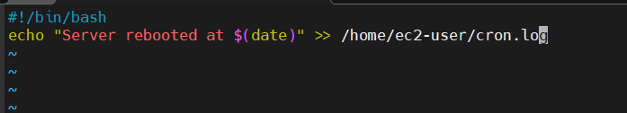
Step 3: Make the Script Executable
chmod 755 /home/ec2-user/ reboot.sh

Step 4: Open the Crontab
crontab -e
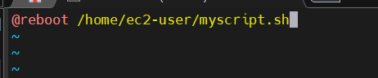
Step 4: Verify the Cron Job
crontab -l
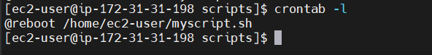
Step 8: Test It
Reboot the EC2 instance:
sudo reboot
